Title

The Analysis of the Presentation and Collection of Data of Weather.ph

I. Project Authors

**Project Consultant**

|  |  |  |
| --- | --- | --- |
| **Name** | **Position** | **Email** |
| Mr. Ernesto Boydon | Professor | ernestob@apc.edu.ph |

**Project Adviser**

|  |  |  |
| --- | --- | --- |
| **Name** | **Position** | **Email** |
| Mr. Paulo Oblepias | Professor | pauloo@apc.edu.ph |

**Project Team**

|  |  |  |
| --- | --- | --- |
| **Name** | **Position** | **Email** |
| Miguel Jaime S. Mayor | Project Manager | msmayor@student.apc.edu.ph |
| Adrian Tobias | Project Researcher | adtobias@student.apc.edu.ph |
| Joanna De Guzman | Project Editor | jddeguzman@student.apc.edu.ph |

II. Introduction

Nowadays, arrangement and management of data has different techniques for different company around the world. These techniques help these companies to increase productivity. With productivity at a high level, surely income will increase too. This study focuses on the improvement on the old algorithm by assigning a new algorithm for the company called Weather.ph. What is Weather.ph? Weather.ph is a company under Aboitiz Equity, and its primary goal is to make all the people in the nation aware about the weather in the different regions of the Philippines. They handle the installation and operation of the weather machines. They have a problem existing in their system which is presentation of data this study makes use of its gathered information and data to focus on exploring that problem.

**2.1 Background of the Problem**

Arrangement and management of data from an old algorithm or way of process of Weather.ph poses some problems, which cause delays in their operations, delay of reaction time due to the lack of no alert process, and no proper storage for their reports. This may hinder their productivity because it breaks and delays the flow of the whole system. The factors that contribute to these problems are the unresponsiveness of the ones who are being taught to troubleshoot through phone. Their reaction time to the broken weather machine is also delayed, because they do not have much of a way to alert them. They service reports can be lost or stolen because it is only stored inside the laptops of the workers and not on a secure and easy accessible place

**2.2 Statement of the Problem**

How do we provide convenience and increase productivity to the Operations and Maintenance Department, which still uses the old algorithm?

**2.3 Objectives**

The researchers of the study have decided that the following are the main specific objectives of the study:

- To improve the algorithm to a better and faster way which its productivity is increased by 50%

- To come up with a proposal of usable methods that can lead into create a algorithm that will solve the problem of Weather.ph completely

- To gather all information and data from such sources like the interviewees, terms and definitions of problem, and related article which contributes in finalizing the best method for the problem.

**2.4 Significance**

The result of this analysis on finding a new algorithm that increases the productivity level of the department and it will result in solving the problem that the Weather.ph is now facing. This method when applied to the new algorithm that is going to be modeled and improved from the old algorithm will defined in this subject. The new algorithm would significantly improve the ease of handling data and information within the company. Specifically, the system will be greatly beneficial to the operations department of the company in handling the equipment used for the company, bring ease to the management and arrangement of data, and increase the reliability against the loss or errors that could occur to the information they require. The system will also greatly benefit the maintenance personnel because they could easily determine the exact quantity of the equipment, the quality, and the availability.

**2.5 Scope and Limitations**

The department that will be using this system are the operations & the maintenance department. The study will not cover other departments such as financial department, Human resources, etc. This system is limited to the operations & maintenance departments. This study is also limited to the improvement of the old system by proposing a new algorithm, which provides convenience and increase in productivity in the Operations and Maintenance department of the company; it does not focus in other problems in the company.

**2.6 Data used to describe Weather Station**

Station – Weather Station Number; Example 000001  
Name – Name of the Weather Station, usually the location or place of the weather station is the name; For example SM North  
Sponsor – Name of the Sponsor; Example APC holdings  
Province – Name of the province where weather station is placed; For example Paranaque  
Region – Region of the weather machine; For example NCR or National Capital Region  
Logger – Name of the logger used for the weather machine; For example GIZMO  
Sensor – Name of the sensor used, usually the company who manufactures it. For example ACE  
PhoneNumber – The phone number which the weather station uses to transmit data; Ex. 09090909090  
Payment – Type of payment for the phone number, either PREPAID or POSTPAID  
Telco – The network which the phone number is subscribe to; SMART, GLOBE, SUN etc  
Gateway – Name of the gateway for the weather machine  
Solar – Solar panelled or not  
Last Session – Last session of transmission of data; Date for example 2015-12-31_11:32  
Signal – Signal strength of the weather station; for example 25  
Timeout – Connection failure; Either no or black, no referring to no connection  
Updated – Last date of update; Date for example 2015-11-23_9:30  
Journal – Comments about the weather station

III. Diagrams

**3.1 Context Diagram**

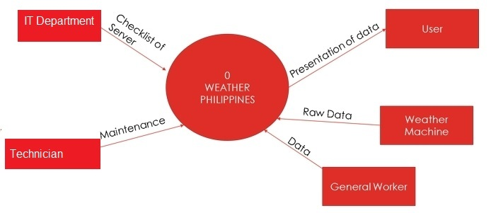

**3.2 Diagram 0**

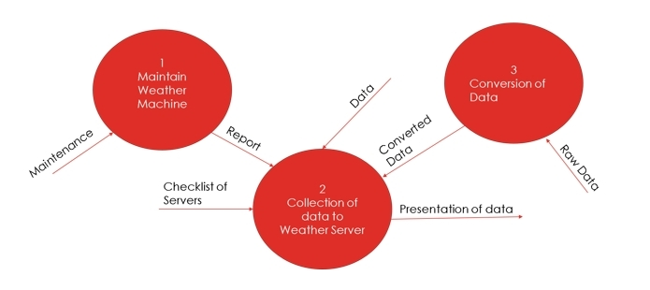

**3.3 Diagram 1**

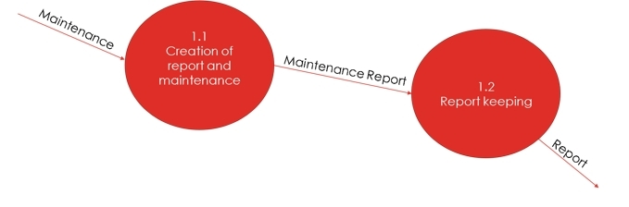

**3.4 Diagram 2**

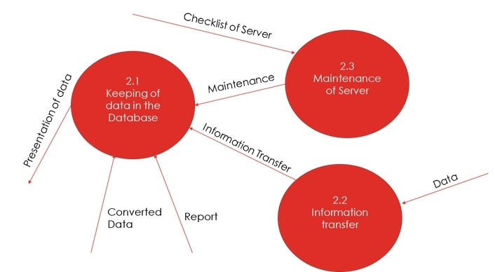

**3.5 Tree Diagram**

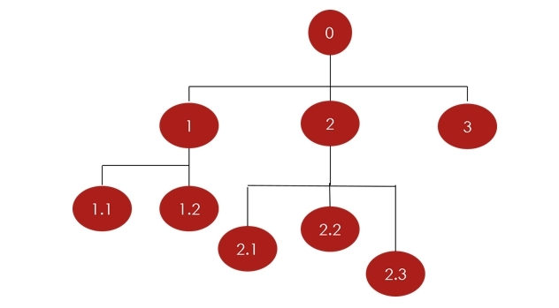

0 – Weather Philippines Diagram

Diagram 0  
1 – Maintain Weather Machine  
2 – Collection of data to Weather Server  
3 – Conversion of Data

Diagram 1  
1.1 – Creation of report and maintenance  
1.2 – Report keeping  
Diagram 2  
2.1 – Keeping of data in the Database  
2.2 – Information transfer  
2.3 – Maintenance of Server

Process Specification

PROCESS SPECIFICATION OF DIAGRAM 0 PRECONDITION OF Process 3 – Conversion of Data

* DATA_UP is matched with DATA_DB specs

POSTCONDITION

* DATA_UP or Converted Data is uploaded to the server

PROCESS SPECIFICATION OF DIAGRAM 1  
  
PRECONDITION OF Process 1.1 – Creation of report and maintenance

* REPORT FORM contains all data needed

POSTCONDITION

* No error from comparison of data of REPORT FORM

PRECONDITION OF Process 1.2 – Report keeping

* REPORT FORM has no null values and all fields are complete

POSTCONDITION

* REPORT FORM + TIMESTAMP to DATABASE

PROCESS SPECIFICATION OF DIAGRAM 2  
  
PRECONDITION OF Process 2.1 – Keeping of data in the Database

* INFO from Process 2.2 and is complete

POSTCONDITION

* New entry for data with current timestamp and then upload to Database

PRECONDITION OF Process 2.2 – Information transfer

* DATA from General Worker is captured

POSTCONDITION

* DATA is uploaded

PRECONDITION OF Process 2.3 – Maintenance of Server

* Checklist of server is checked and complete

POSTCONDITION

* Maintenance is applied to server